**PROJECT REPORT**

**Project – Credit Underwriting**

*Submitted towards the partial fulfillment of the criteria for award of Genpact Data Science Prodegree by Imarticus*

*Submitted By:*

*Gaurav Rai*

*Alwin*

*Naeem*

*Sabari*

*Course and Batch: DSP09-2018*



# Abstract

**Keywords**

*Disclaimer: *Data shared by the customer is confidential and sensitive, it should not be used for any purposes apart from capstone project submission for DSP. The Name and demographic details of the enterprise is kept confidential as per their owners’ request and binding.*

# Acknowledgements

We are using this opportunity to express my gratitude to everyone who supported us throughout the course of this group project. We are thankful for their aspiring guidance, invaluably constructive criticism and friendly advice during the project work. I am sincerely grateful to them for sharing their truthful and illuminating views on a number of issues related to the project.

Further, we were fortunate to have Tharangini Ma’am, Rahul Sir and Avisek Sir as our mentor. They have readily shared their immense knowledge in data analytics and guided us in a manner that the outcome resulted in enhancing our data skills.

We wish to thank, all the faculties, as this project utilized knowledge gained from every course that formed the DSP program.

We certify that the work done by us for conceptualizing and completing this project is original and authentic.

Date: November 10, 2018

Team Dolphin Members: Gaurav Rai, Alvin Antony, Naeem & Sabari

Place: Bangalore

# Certificate of Completion

I hereby certify that the project titled “Project – Credit Underwriting (Using Python)” was undertaken and completed under my supervision by Gaurav Rai, Alvin Antony, Naeem & Sabari (Members of Team Dolphin) from the batch of DSP 09

Mentor: Tharangini

Date: November 10, 2018

Place – Bangalore

Table of Contents [Sample purpose only]

Abstract 2

Acknowledgements 2

Certificate of Completion 3

CHAPTER 1: INTRODUCTION 5

1.1 Title & Objective of the study 5

1.2 Need of the Study 5

1.3 Business or Enterprise under study 5

1.4 Business Model of Enterprise 5

1.3 Data Sources 5

1.5 Tools & Techniques 5

1.6 Infrastructure Challenges 6

CHAPTER 2: DATA PREPARATION AND UNDERSTANDING 6

2.1 Phase I – Data Extraction and Cleaning: 6

2.2 Phase II - Feature Engineering 7

2.3 Data Dictionary: 8

2.4 Exploratory Data Analysis: 8

CHAPTER 3: FITTING MODELS TO DATA 8

3.1 LOGISTIC REGRESSION MODEL 9

CHAPTER 4: INFRASTRUCTURE CHALLENGES 14

CHAPTER 5: RECOMMENDATIONS AND CONCLUSION 15

CHAPTER 6: REFERENCES 15

**List of Figures**

**List of Tables**

# CHAPTER 1: INTRODUCTION

## Title & Objective of the study

This project is being done to fulfill a requirement of XYZ Financial Institution (XYZ FI) which issues loan to customers based on their application. End product should help XYZ FI to help make decision to pass a loan or not.

## Need of the Study

Based on the data that is available during loan application, build a model to predict default in the future. This will help the company in deciding whether or not to pass the loan.

## 1.3 Business or Enterprise under study

.XYZ Corp which is into loan business.

## 1.4 Business Model of Enterprise

To manage credit risk by using the past data and deciding whom to give the loan to in the future. The text files contain complete loan data for all loans issued by XYZ Corp. through 2007-2015. The data contains the indicator of default, payment information, credit history, etc.

The data should be divided into train (June 2007 - May 2015) and out-of-time test (June 2015 - Dec 2015) data. You will have use the training data to build models/analytical solution and finally apply it to test data to measure the performance and robustness of the models.

'issue_d' variable is used to divide the data in the above time periods, the variable is in <month>-<year> format.

A statistical data model to predict the probability of default, and choose a cut-off based on which is suitable. This will help the company in deciding whether or not to pass the loan

## Data Sources

As provided in the project link. Data is in fixed width format and it needs to be consumed accordingly in Python.

<https://drive.google.com/open?id=1mIf6ckeaDMg2dHWLYRD-80Kh1oB2wFWu>

## 1.5 Tools & Techniques

Tools:

Python programming language. In Python below packages will be used:

Pandas, OS, Numpy, StatsModel/Scikitlearn, matplotlib (relevant python package for visulalization)

Techniques:

Pre-Modelling Steps:

* Exploratory Data Analysis – Helps in detecting NAs and Outliers
* Data Cleaning – NA imputations and Outlier correction
* Data Consumption
* Feature Engineering

Modelling Steps: Since this is a classification problem we have uses below Logistic Regression technique and provided the prediction result based on Precision, Recall, AUC, etc.:

* Logistic Regression

## 1.6 Infrastructure Challenges

Due to the large size of the dataset memory management steps had to be introduced for smooth running of the project.

# CHAPTER 2: DATA PREPARATION AND UNDERSTANDING

One of the first steps we engaged in was to outline the sequence of steps that we will be following for our project. Each of these steps are elaborated below

## 2.1 Phase I – Data Extraction and Cleaning:

* **Missing Value Analysis and Treatment:** Missing values were imputed with below techniques:
  + **Categorical Data:** Mode was used
  + **Quantitative Data:** Median was used (to reduce the impact of outliers)

Also if train dataset had all null values then those needs to be removed as median or mode cannot be calculated over all null in train dataset.

* **Handling Outliers:** Flooring (<1 percentile) were replaced with 1 percentile values and Capping (> 99 percentile) values were replaced with 99 percentile values

## 2.2 Phase II - Feature Engineering

After above steps, features were selected based on the below criteria:

* All columns which were completely null in complete or train dataset were removed as those columns might not add any value to the analysis. Also columns like id and member_id were removed as those values serve only identification purpose in the persistence layer and do not contain any statistical significance.
* There were several categorical variables for which there were many unique values which had to be handled as with current setup we were not able to convert them to dummies / bins (constant memory error issues). Hence 2 step strategy was followed:
  + Using Pandas crosstab function proportion of categorical variables was calculated wrt dependent variable ‘default_ind’. Then 2 broad categories of 0 and 1 was classified into.
  + After doing above steps there still many proportion categories left which would have created memory issues while dummy variable creation. So variables which were having very high distinct count of values were identified for which category pruning was done to reduce category of variables:

emp_title

desc

title

zip_code

addr_state

earliest_cr_line

last_pymnt_d

last_credit_pull_d

* + For the above variables 10 bins were identified and there were categorized accordingly:

0 to 0.1, 0.1 to 0.2 …. 0.8 to 0.9 and 0.9 to 1

After the above steps were followed variables were quite reduced for dummy creation step.

* Dummy variables were created and dataset was sampled into test and train with the introduction of Intercept = 1 variable as internally python internally needs this variable as a multiplier to do all calculations.
* After dummy creation we need to reduce the count of variables for further analysis as all variables do not add value to analysis. Below approach was followed:
  + All variables with a single unique value was removed
  + Highly imbalanced variables were also removed like if a column has 99% of the values same then those were removed as it was causing issues during further analysis.
* Multicollinearity check was done through Variance Inflation Factor method of statsmodel package in python and for each iteration variables having VIF>10 were removed.

## 2.3 Data Dictionary:

Attached data dictionary was referred to



## 2.4 Exploratory Data Analysis:

Exploratory Data Analysis was done programmatically as there were too many variables to explore the data visually. Missing values were imputed via median and mode. Outliers were capped and floored through quantile functionality.

# CHAPTER 3: FITTING MODELS TO DATA

**Logistic Regression:** Since it is a classification problem so our natural model choice Logistic. We tried using SVM model with Gridsearch for best model but due to infrastructure computing issues the modelling steps pertaining to SVM or Gridsearch could not complete itself. I am attaching the code for the same along with this delivery. So for our final analysis we stick to Logistic Regression.

## 3.1 LOGISTIC REGRESSION MODEL

Logistic Regression model was implemented using SciKit Learn library of Python (LogisticRegression() module was used). We must note here that functionally default_ind value of 1 is not desirable as it means that customer will default on the loan taken. We will try out modelling steps based on cut-off probability values discussed further.

**Cut-off probability = 0.5** for default_ind value to be 1 (based on equal binary probabilities of 0 & 1) to classify predictions to 0 or 1. Results are as below:

* Confusion Matrix is as shown below:

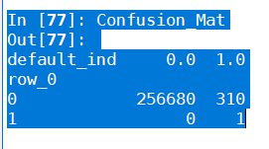

* Accuracy - 99.88%
* AUC(Area Under Curve) – 74.37%
* Recall Score - 0.003215 (Very Near to 0)
* Precision Score – 1

ROC Curve: 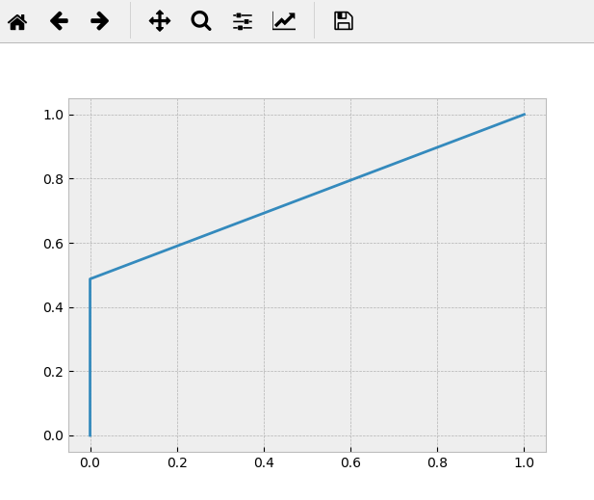

Interpretation of above results:

* Accuracy is fine
* AUC is okay but we will have to evaluate other cut-off probabilities to arrive at any conclusion
* Recall score is very near to zero which is also ok considering that the desirable result for is default_ind to be 0 (not successful)
* But precision score of 1 is hinting (considering desirable score of 0 for default_ind column) that it might not be ok to consider this model with cut-off = 0.5. We will evaluate this further.

**Cut-off probability = 0.3** for default_ind value to be 1 with below results

* Confusion Matrix is as shown below:

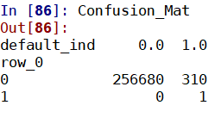

* Accuracy - 99.88%
* AUC(Area Under Curve) – 74.54%
* Recall Score - 0.003215 (Very Near to 0)
* Precision Score – 1

We see from the above results that AUC has increased. So we would try further lower cut-off probability values.

**Cut-off probability = 0.2** for default_ind value to be 1 with below results

* Confusion Matrix is as shown below:

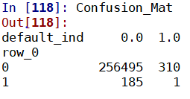

* Accuracy - 99.81%
* AUC(Area Under Curve) – 74.72%
* Recall Score - 0.003215 (Very Near to 0)
* Precision Score – 0.00537 (Very Near to 0 and highly desirable)

When we reduced the cut-off value we see that precision score has improved remarkably with very little trade off with accuracy. We need to take the optimumcutoff value so we will try it with value 0.10

**Cut-off probability = 0.10** for default_ind value to be 1 with below results

* Confusion Matrix is as shown below:

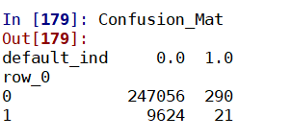

* Accuracy – 96.14%
* AUC(Area Under Curve) – 75.53% It has increased
* Recall Score - 0.0675 (Very Near to 0)
* Precision Score – 0.00217 (Very Near to 0 and highly desirable)

Let’s try one more cut-off value in quest for optimum cut-off value

**Cut-off probability = 0.05** for default_ind value to be 1 with below results

* Confusion Matrix is as shown below (This matrix itself indicates that is high number of false negatives so we need to look closely here):

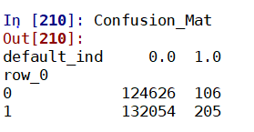

* Accuracy – 48.57% - Degrades drastically
* AUC(Area Under Curve) – 71.43% It has decreased
* Recall Score - 0.65916 Not desirable considering inverse nature of default_ind values.
* Precision Score – 0.00154 (Very Near to 0 and highly desirable)

Since the nature of ROC curve is that for cut-off value it increases and then starts to decrease or vice versa, so our optimum cut-off value must lie in between 0.1 and 0.05. Also for above cut-off accuracy degraded drastically so above result is discarded right away.

**Cut-off probability = 0.08** for default_ind value to be 1 with below results

* Confusion Matrix is as shown below:

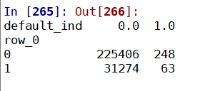

* Accuracy – 87.73% - Degrades drastically
* AUC(Area Under Curve) – 75.46% It has decreased
* Recall Score - 0.20257 mildly ok
* Precision Score – 0.00201 (Very Near to 0 and highly desirable)

Since AUC decreased we will try out one more cut-off value 0.09

**Cut-off probability = 0.09** for default_ind value to be 1 with below results

* Confusion Matrix is as shown below:

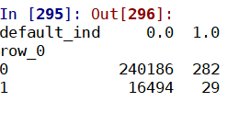

* Accuracy – 93.47% - Increased significantly as compared to previous model
* AUC(Area Under Curve) – 75.55% It has increased
* Recall Score - 0.09324 highly ok as compared to previous model
* Precision Score – 0.001755 (Very Near to 0 and highly desirable)

**ROC Curves**

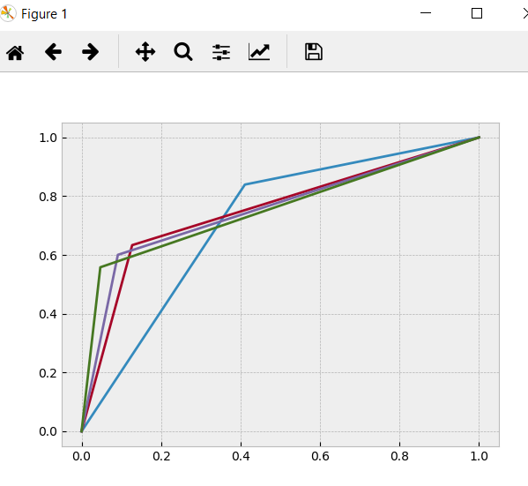

Also when we did the VIF check we found that none of the values were > 10 so our analysis was on all significant features. So our final model will be with cut-off value = 0.09

**Let’s dive deeper into the results of the model with cut-off = 0.09**

**Accuracy - 93.47% -** This is fantastic considering the fact we had to fine tune our model to bring at par other metric values.

**AUC – 75.55% -** This was the best AUC value that we have obtained during our modelling exercise.

**Recall Score - 0.09324 –** Recall score is calculated by the formula = TP[True Positive]/(TP[True Positive]+FN[False Negative]).

Let’s try to understand the business significance of TP (value of 1). This is a case in which we have predicted to customer to default and customer defaulted. If this value is very less then it is good for business. Usually Recall Scores are best when they are near to 1 (in other business circumstances).

**Precision Score - 0.001755** Precision score is calculated by formula = TP/(TP+FP[False Positive])

Like mentioned for recall score if this value is close to zero for this business case then it is good. Usually Precision Scores are best when they are near to 1 (in other business circumstances).

**Conclusion: Champion model is with cut-off value = 0.09**

CHAPTER 4: INFRASTRUCTURE CHALLENGES

Since this has been a very large data set in both dimensions – rows as well as columns there was constant memory issues erupting. This was tackled by memory management steps in the code in which dataframes which were redundant were being removed diligently.

CHAPTER 5: RECOMMENDATIONS AND CONCLUSION

**Below are the details of the Champion model**

**Cut-off probability = 0.09** for default_ind value to be 1 with below results

* Confusion Matrix is as shown below:



* Accuracy – 93.47% - Increased significantly as compared to previous model
* AUC(Area Under Curve) – 75.55% It has increased
* Recall Score - 0.09324 highly ok as compared to previous model
* Precision Score – 0.001755 (Very Near to 0 and highly desirable)

CHAPTER 6: REFERENCES

**Discussion thread related to logistic regression were referred from below sites:**

[**https://stackoverflow.com/**](https://stackoverflow.com/)

**https://stackexchange.com/**

[**https://www.analyticsvidhya.com/**](https://www.analyticsvidhya.com/)